

Network-Based Application Development (ITIS 4166/5166) **Summer 19**

**Group Project - phase 1**

**(Submission: May 30th, 11:59 PM)**

This Assignment provides the first step towards developing a Java web application. It is intended to (re)familiarize students with HTML/JSP development and will let them apply the programming skills that you learn in *Murach’s Java Servlets and JSP* by creating a ***Product Management Application***.

**Design the frontend by using HTML and CSS**

For this phase, you’ll create several JSP files:

1. to add, edit, and delete a product to/from a product list
2. to authenticate, and register a user. No backend functionality is needed. (*Prerequisites: chapters 1-4*)

Index page (index.jsp)

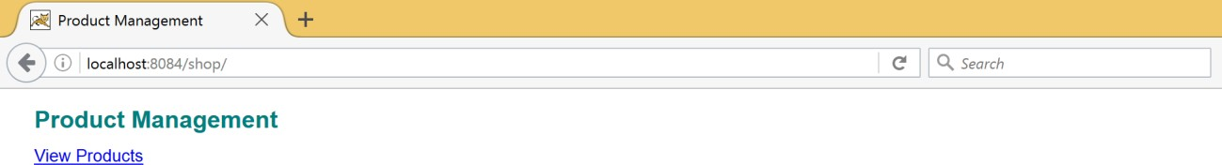

Products page (products.jsp)

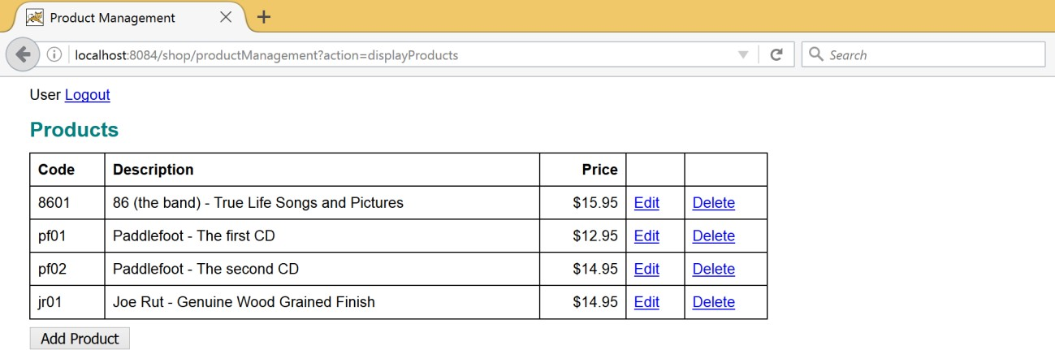

Product page (product.jsp)

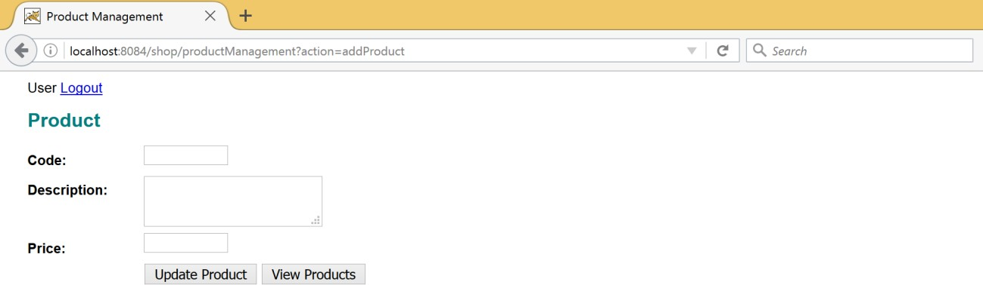

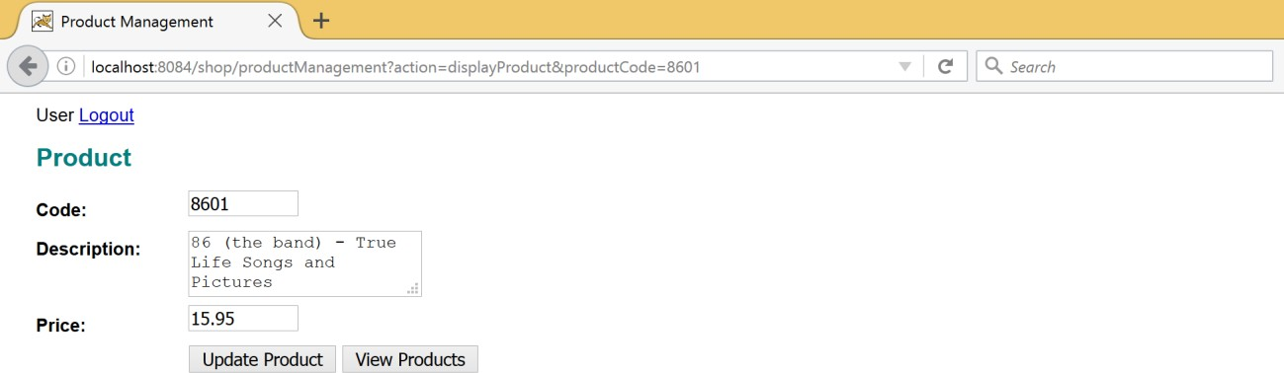

Delete Product page (confirmDelete.jsp)

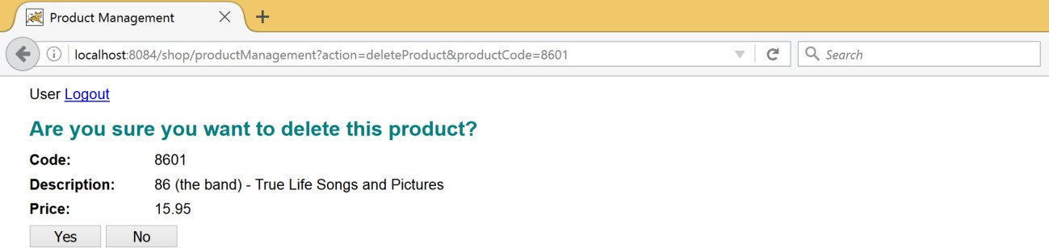

Login page (login.jsp)

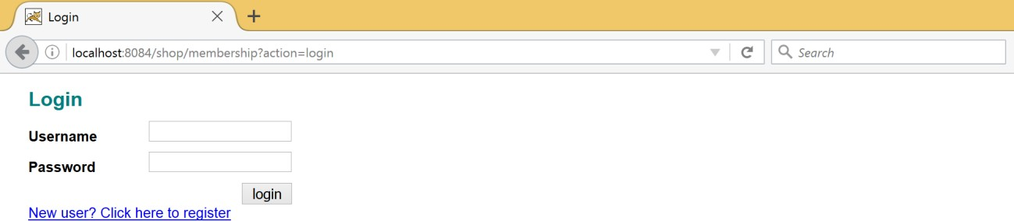

Signup page (signup.jsp)

